**SERGIO ESTEBAN FORERO PINZÓN**

**PERSONAL SOFTWARE PROCESS: TRABAJO 1**

PROJECT PLAN SUMMARY:

|  |  |  |  |  |
| --- | --- | --- | --- | --- |
| **TIME IN PHASE** | **PLAN** | **ACTUAL** | **TO DATE** | **TO DATE%** |
| **Planning** |  | 6 | 6 | 6,9% |
| **Design** |  | 13 | 13 | 15,11% |
| **Code** |  | 51 | 51 | 59,30% |
| **Compile** |  | 5 | 5 | 5,8% |
| **Test** |  | 11 | 11 | 12,7% |
| **TOTAL** | 120 | 86 | 86 |  |

|  |  |  |  |  |
| --- | --- | --- | --- | --- |
| **DEFECTS INJECTED** | **PLAN** | **ACTUAL** | **TO DATE** | **TO DATE%** |
| **Planning** |  |  |  |  |
| **Design** |  |  |  |  |
| **Code** |  | 1 | 1 | 100% |
| **Compile** |  |  |  |  |
| **Test** |  |  |  |  |
| **TOTAL** | 2 |  |  |  |

|  |  |  |  |  |
| --- | --- | --- | --- | --- |
| **DEFECTS REMOVED** | **PLAN** | **ACTUAL** | **TO DATE** | **TO DATE%** |
| **Planning** |  |  |  |  |
| **Design** |  |  |  |  |
| **Code** |  | 1 | 1 | 100% |
| **Compile** |  |  |  |  |
| **Test** |  |  |  |  |
| **TOTAL** | 2 |  |  |  |

PSP TIME RECORDING LOG

|  |  |  |  |  |  |  |
| --- | --- | --- | --- | --- | --- | --- |
| **Project** | **Phase** | **Start Date and time** | **Int Time** | **Stop Date and time** | **Delta time** | **Comments** |
| Psp0 | Planning | 8:46 | 7 | 8:53 | 1 |  |
| Psp0 | Design | 11:05 | 15 | 11:20 | 2 |  |
| Psp0 | Code | 11:20 | 55 | 12:15 | 10 |  |
| Psp0 | Compile | 12:15 | 5 | 12:20 | 0 |  |
| Psp0 | Code | 12:20 | 6 | 12:26 | 0 |  |
| Psp0 | Test | 12:26 | 12 | 12:38 | 1 |  |
|  |  |  |  |  |  |  |

PSP DEFECT RECORDING LOG

|  |  |  |  |  |  |  |  |
| --- | --- | --- | --- | --- | --- | --- | --- |
| Project | Date | Number | Type | Inject | Remove | Fix time | Fix Ref |
| PSP0 | 1/24/2015 | 1 | 70 | Code | Code | 11:15 | 11:16 |

**Desc**: No se estaban cargando bien los datos del archivo txt

**PRUEBAS REALIZADAS**

|  |  |  |  |  |
| --- | --- | --- | --- | --- |
| **TEST** | **EXPECTED VALUE** | | **ACTUAL VALUE** | |
|  | **MEAN** | **STD. DEV** | **MEAN** | **STD. DEV** |
| **DATOS 1** | 550.6 | 572.03 | 638.9 | 625.6339 |
| **DATOS 2** | 60.32 | 62.26 | 60.32 | 62.2558 |

Prueba No 1:

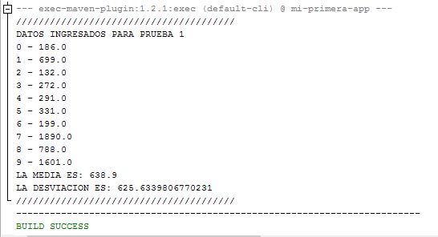

Prueba No 2:

